Name: Class:
Introduction
You can apply the fundamental electrochemical cell concepts you have learned to any cell. All electrochemical cells will have an anode and a cathode. The reactants at these electrodes will be separated within the cell so that electrons cannot be exchanged directly: they must travel through the external circuit. There will also be a substance within the cell that provides mobile ions that maintain electrical neutrality throughout the cell.
The nickel–hydrogen cell is a relatively new type of battery that was developed for the US space program. They are currently used in the International Space Station (ISS) for energy storage. The ISS circles the Earth every 90 minutes. While it is in sunlight, solar cells may be used to generate electricity. The nickel–hydrogen cells store some of this electrical energy and release it again when the ISS is in darkness.
Each cell consists of a nickel–nickel oxyhydroxide (NiOOH) cathode, and a platinum anode at which hydrogen gas is oxidised. The electrolyte is concentrated potassium hydroxide, about 30% m/m. The cell is a pressure vessel, since it must hold a significant quantity of hydrogen gas. It is thus very expensive but long-lived, with a lifespan of up to 20 years. Each cell consists of many ‘stacks’. One such stack is shown below.

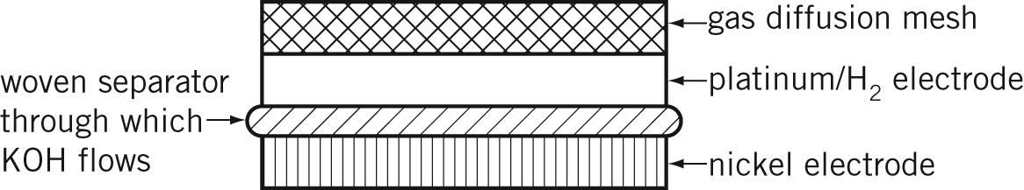

The major electrode reactions during the discharge process are listed:
Cathode: NiOOH(s) + H₂O(l) + e– → Ni(OH)₂(s) + OH–(aq)
Anode: H₂(g) + 2OH–(aq) → 2H₂O(l) + 2e–

No. | Question | Answer
 | Why is it necessary to have energy-storage cells such as the nickel–hydrogen battery aboard the International Space Station?
What is the oxidation number of nickel in:
a NiOOH
b Ni(OH)₂
During the recharging process, what is the
a reductant?
b oxidant?
 | Write a balanced redox equation for the discharge process.
 | Calculate the concentration, in mol L^{–1}, of the KOH electrolyte if 50.0 mL of electrolyte has a mass of 54.8 g.
 | How would the concentration of the electrolyte change during the recharging process?
How would the pressure inside the cell change during:
a recharging?
b discharge?
 | What would be three requirements of the material used for the separator?
 | What would happen if the separator were left out of the stack?
 | State one advantage and one disadvantage of this cell.

